OKC RNY New Beginnings Newsletter November 2004
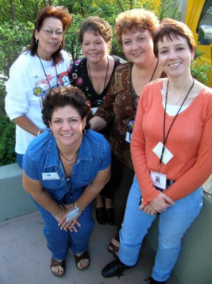  Support Group Board Members  Tonja Martin, Founder  Becky Carlile  Johnnie Kay Hogan  Leanne Lepley  Sherry Gates High  Sybil Ankle |  | Meeting Information  Edmond/North OKC  4th Thursday of each Month 5:45 to 8:15 pm  Edmond Medical Center  1 S. Bryant  Classroom 1 (Ambulatory  Care Pavilion)  Edmond, Oklahoma  South Oklahoma City  2nd Saturday of each Month 9:30am to noon  Physician’s Hospital of Oklahoma Cafeteria  3100 SW 89th Street  Oklahoma City, OK  The group is open to Pre-Ops, Post-Ops, and their friends and families  Please note Change in time for December South Meeting From 12-3 pm for our Winter Holiday Party.
INSTANT SPICED TEA MIX  2 C. Sugar Free Tang  1/2 C. Sugar Substitute  1 Package Sugar Free Pre-Sweetened Lemonade Mix  1/2 C. Instant Tea  1/2 Tsp. Cinnamon  1 Tsp. Cloves  Combine all ingredients well and store in a covered jar.  Place 2 to 3 teaspoons in a glass, fill with boiling water. | WORD SEARCH FUN |  | OKC RNY NEW BEGINNINGS  “WINTER CELEBRATION”  Lunch Potluck and Gift Exchange Game*  Bring your favorite dish ready to share  DECEMBER 11, 2004  12:00 P.M. – 3:00 P.M.  PHO Hospital Cafeteria  Please RSVP no later than December 4th to  OKCRNYNEWBEGINNINGS@yahoogroups.com  *Child Care provided by RSVP only for $1 per hour  per child  *Gift limit is $10 and is not required to attend  Turkey, Ham, Cheese, Coffee, Tea and Water  Provided
  VITAMINS | SUGARFREE | THANKFUL
  WATER | PROTEIN | EXERCISE
  JOURNEY | FRIEND | SUPPORT
  TOGETHER | CHEW | HEALTH
  V | B | E | S | I | C | R | E | X | E
  R | I | A | J | O | U | R | N | E | Y
  W | A | T | E | R | T | A | W | H | R
  S | U | G | A | R | F | R | E | E | E
  U | E | N | F | M | R | S | H | A | H
  P | C | E | A | R | I | L | C | L | T
  P | R | O | T | I | E | N | M | T | E
  O | K | E | C | O | N | R | S | H | G
  R | Y | E | C | N | D | J | A | R | O
  T | H | A | N | K | F | U | L | T | T
Comments? Questions? Suggestions?
Please e-mail Becky Carlile beckyraneec@yahoo.com

